Railway Reservation System

Aim:

To create UML diagram for Railway Reservation System using umbrello tool.

Class Diagram

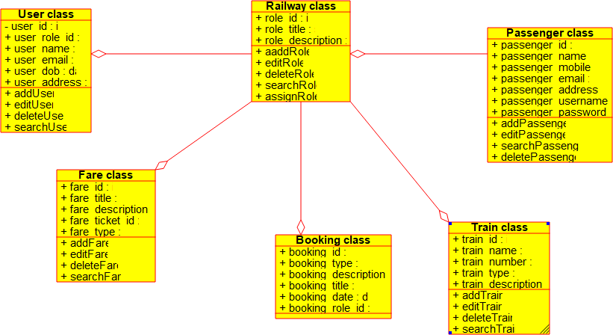

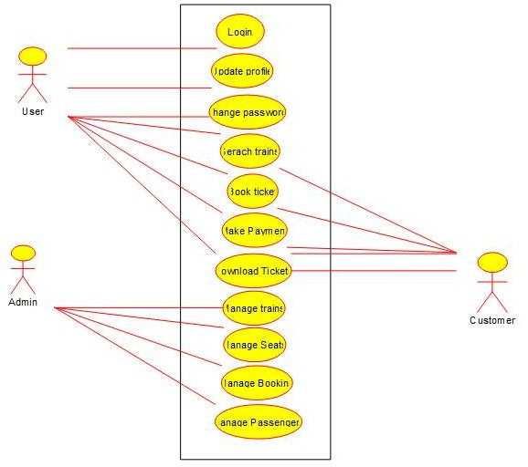

State Diagram

